2014 Pew American Trends Panel

Waves 1 and 2: Media Survey and Nonresponse Follow-up

Methodology Report

Submitted to:
The Pew Research Center
1615 L Street, NW
Suite 700
Washington, DC 20036

Prepared by:
Abt SRBI
Courtney Kennedy
Chintan Turakhia
Dean Williams
275 Seventh Avenue, Suite 2700,
New York, New York 10001
(212) 779-7700
www.srbi.com

May 28, 2014

I. SUMMARY
The American Trends Panel (ATP) is a national, probability-based online panel of adults in the United States living in households. Adults who use the internet participate in the panel via self-administered Web surveys, and adults who do not use the internet participate via computer assisted telephone interviewing (CATI) or mail. The first panel survey, called the Polarization Study Media Wave, was fielded for the Pew Research Center by Abt SRBI March 19 through April 29, 2014. The survey was administered in English and Spanish. In total, 3,308 ATP members completed the survey, with 2,901 participating by Web and 407 participating by computer assisted telephone interviewing (CATI). The responding sample is weighted to account for differential probabilities of selection into the panel as well as differential nonresponse to the recruitment survey, the panel invitation, and the panel survey itself. The margin of sampling error for full sample weighted estimates is ±2.19 percentage points.

A nonresponse follow-up study (called Wave 2) was conducted in conjunction with the Media Study. This follow-up effort was designed to verify whether panelists had received their ATP welcome packet, maximize participation in the Media Study, and gain insight as to why some ATP members had not participated in the Media Study. The nonresponse follow-up was conducted via CATI from April 17 - 27, 2014. In total, 2,228 ATP members were called in this effort and 1,124 completed the follow-up interview.

II. SAMPLE DESIGN
The target population for the Media Study was non-institutionalized persons age 18 and over, living in the US. The sample consisted of all 5,339 original members of the ATP, which is a probability-based online panel of adults in the United States. The Media Study featured a simultaneous mixed-mode design. Panelists who use the internet and provided an email address participated via self-administered Web survey, and adults who do not use the internet (or do but did not provide an email address) participated via CATI.

III. QUESTIONNAIRE DEVELOPMENT AND TESTING
The questionnaire was developed by the Pew Research Center in consultation with Abt SRBI. In order to improve the quality of the data, the web program was rigorously tested by Abt SRBI project management team and Pew researchers. Test scenarios were created for all possible combinations of sample variables and question filters to ensure all skip logic was functioning correctly. Test data was then analyzed to determine that all logic was correct.

IV. DATA COLLECTION PROTOCOL FOR THE MEDIA STUDY
Recruitment for the Media Study was implemented on a staggered schedule because this was the first ATP survey, and recruitment for the ATP itself was conducted immediately before the Media Survey on a staggered schedule. Currently all ATP panelists have been recruited from a large (n=10,004) national overlapping dual frame landline and cell phone random digit dial (RDD) survey conducted for the Pew Research Center. At the end of that RDD survey, respondents were invited to join the panel. The invitation was extended to all respondents who use the internet (from any location) and a random subsample of respondents who do not use the internet. The RDD survey was conducted from January 23rd to March 16th, 2014, in English and Spanish. The RDD survey field period was divided into three phases of roughly equal length (A, B, and C). In order to avoid a long lag between when the Phase A and B respondents were invited to the panel and when they were asked to take their first panel survey (the Media Study), the panelists from Phase A were invited to complete the Media Survey first, followed by the panelists from Phases B and C, respectively. The initial email inviting ATP members to participate in the Media Study was sent March 19 through April 1, 2014, depending on when the panelist was recruited. The 1st reminder email was sent March 25 through April 10, 2014. The 2nd reminder email was sent April 3 through April 14, 2014. The third reminder email was sent April 9 through April 21, 2014.

At the start of the Media Study, 561 ATP members were in the CATI arm of the panel. These panelists had provided a residential address during the RDD recruitment survey, but they did not provide an email address. The design of the Media Study called for interviewing these panelists on the phone via CATI. The CATI effort was conducted March 27 through April 28, 2014. Landline and cell phones numbers were called as many as 10 times. Refusal conversion was attempted on soft refusal cases in both the landline and cell phone samples. Calls were staggered over times of day and days of the week to maximize the chance of making contact with potential respondents. Each number received at least one daytime call.

ATP panelists age 18 to 25 and those who reported being Hispanic/Latino in the RDD recruitment survey were offered a post-paid incentive of $10 for completing the Media Study. All other panelists were offered a post-paid incentive of $5. The differential incentive amounts were designed to increase panel survey participation among groups that traditionally have low survey response propensities.

V. DATA COLLECTION PROTOCOL FOR THE NONRESPONSE FOLLOW-UP
The nonresponse follow-up study was conducted in conjunction with the Media Study. The follow-up effort was designed to verify whether panelists had received their ATP welcome packet, maximize participation in the Media Study, and gain insight as to why some ATP members had not participated in the Media Study. Interviews were in English and Spanish. After determining that the named panel member was on the phone, the panelist was asked if they had received their welcome packet containing the welcome letter, brochure and $10 bill. Email and address information was confirmed and updated for panel members who indicated they did not receive their welcome packet in order to resend welcome packets accordingly to those panel members. All panel members were asked if they would be willing to receive future survey invitations via text message. The panel member was then asked if they would be able to complete the current web survey in the next few days, reminded that they would receive $5 or $10 for completing the survey and then asked if they would like to be emailed the web link. If the panel member requested the web link be emailed, the interviewer then verified the panel member’s email address and the CATI system instantly sent out an email with the web link to the panel member. Finally, panel members were asked if they had any other issues or problems completing ATP surveys. Panel members who reported technical problems had the problem recorded by the interviewer and an Abt SRBI project manger called them back. The nonresponse follow-up was conducted via CATI from April 17 through April 27, 2014. In total, 2,228 ATP members were called in this effort and 1,124 completed the follow-up interview.

Table 1. Outcomes from the Nonresponse Follow-up
 | Cases | % of Completions
Completed interviews | 1,124 | 100%
Reported did not receive welcome packet | 246 | 22%
Reported did not know if received welcome packet | 77 | 7%
Gave new residential address | 97 | 9%
Gave new email address | 98 | 9%
Agreed to text message invites | 727 | 65%
Gave new cell phone number | 184 | 16%
Survey invitation emails sent | 1,053 | 94%
Received email and completed Media Study survey | 332 | 30%
Received email and began Media Study survey | 54 | 5%
Reported technical difficulties | 24 | 2%
Mode change due to technical difficulties | 10 | 1%
Requested to be removed from panel (hard refusal, refusal to give info, or request to be removed) | 34 | 3%

VI. WEIGHTING
Survey weights are needed to support reliable inference from the panel to the target population of US adults. The final survey dataset contains a full sample weight (WEIGHT_W1). The weights are compute in three main stages:
- Base weight adjusting for differential probabilities of selection
- Propensity adjustment for nonresponse to the panel invitation
- Calibration to demographic distributions for the target population

Base Weight
A base weight is computed for all ATP members. The base weight adjusts for factors affecting the probability that the individual was selected for the panel. This probability comes from the survey in which the respondent was recruited. Currently, all ATP members were recruited through a probability-based, national overlapping dual frame landline and cell phone RDD survey. The target population for the RDD survey was identical to the target population for the ATP (adults living in households in the US). The RDD survey was administered in English and Spanish. All respondents to the RDD survey were invited to join the panel, except some individuals who do not use the internet, as this group was subsampled for the panel. In the landline sample of the RDD survey, one adult was randomly selected from within the household. Interviewers asked to speak with either the youngest male or youngest female at home at the time of the call. In the cell sample of the RDD survey, interviews were conducted with the person who answered the phone, provided they were age 18+ and spoke English or Spanish.

The base weight was computed using single frame estimation to adjust for the probability that the respondent’s phone number was selected from the sampling frame, the overlap in the landline and cell phone frames, and the within household selection in the landline sample. For most panel members, the base weight is equal to the variable NEWWT1 in the 2014 Pew Polarization Study dataset and can be expressed as:

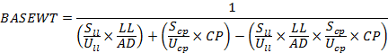
Where:
LL =1 if respondent has a landline phone
=0 if respondent has no landline phone
(OR number of landlines on which the respondent could have been reached)

CP =1 if respondent has a cell phone
=0 if respondent has no cell phone
(OR number of cell phones on which the respondent could have been reached)

S_{ll}= number of cases released in the landline sample

S_{cp}=number of cases released in the cell phone sample

U_{ll}=size of the landline RDD frame

U_{cp}=size of the cell phone RDD frame

AD=number of adults in the household (1, 2, 3 or more)

For a subset of the ATP members, an additional adjustment is included in the base weight to account for the fact that they belong to a group that was subsampled for invitation to the panel. In the RDD survey, non-internet users were subsampled at a rate of 25% from January 23, 2014, through February 5, 2014, but they were not subsampled (100% invited) from February 6, 2014 through the end of the field period. Internet users who agreed to join the panel but did not have an email address were taken at 100% from January 23, 2014, through February 5, 2014, but they were subsampled at a rate of 25% from February 6, 2014, through the end of the field period. The base weight of the affected cases was multiplied by the inverse of the subsampling rate (1 / .25 = 4).

Adjusting for Nonresponse to the Panel Invitation
The panel invitation featured a $10 post-paid incentive for agreeing to join and a fixed post-paid incentive for each panel survey completed. Hispanics/Latinos and adults age 18 to 25 were offered $10 per panel survey, and all other invitees were offered $5 per survey. The differential incentives were designed to preemptively offset anticipated differential response rates across these groups. In total, 9,810 RDD survey respondents were invited to join the ATP and 5,339 accepted, yielding a panel acceptance rate of 54.4%. To the extent that those joining the panel may be different from those not joining, there is a risk that estimates from the panel could be subject to nonresponse bias. A propensity score adjustment was computed to adjust for differential nonresponse to the panel invitation.

A logistic regression model was estimated in which accepting the panel invitation was regressed on sampling frame, incentive amount ($10/$5 per survey), internet user, race, marital status, child in the household, age, education, religious service attendance, household income, frequency of voting, opinion of the Tea Party (agree/disagree), whether or not they contacted an elected official in the last two years, political ideology, and statistically significant 2-way interactions (p<.05). Hispanic ethnicity was excluded from the model because it was collinear with the incentive variable. Gender and the number of adults in the household were not predictive and excluded from the model. The set of predictors considered for the model are variables that are routinely measured in surveys conducted for the Pew Research Center for the People & the Press. The significant predictors used in the final model are presented in Table 2.

The estimated propensities were used to divide cases into approximately equal size groups using the quintiles of the estimated propensity score. Quintiles have been found to be effective in capturing most of the variation. The propensity score adjustment was computed as the inverse of the response rate in each quintile. This approach helps to protect against model misspecification, relative to using the inverse of the response propensities.

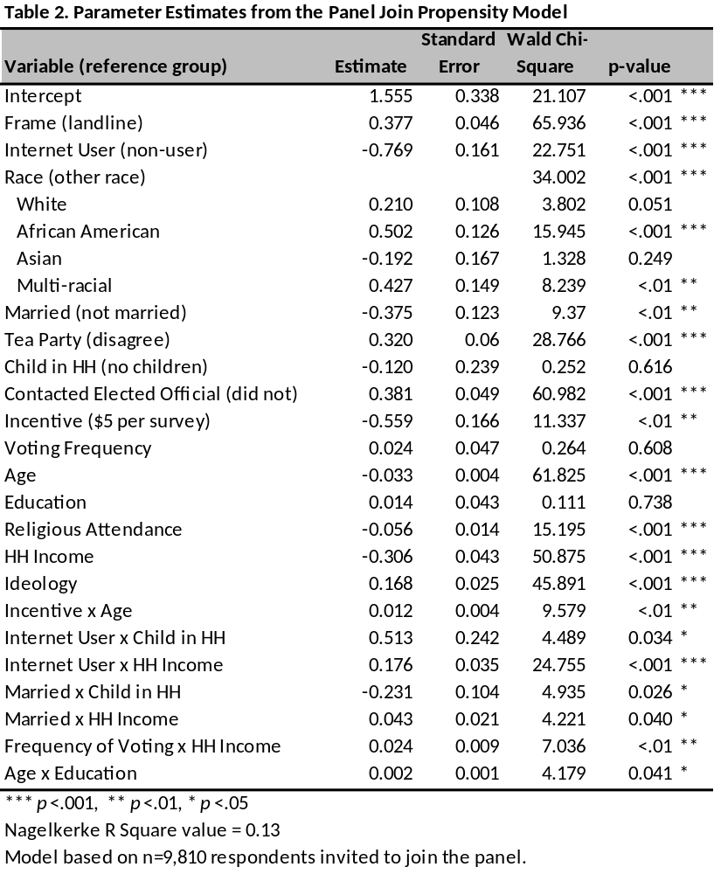
Calibration to Target Population Controls
In the final stage of weighting, the nonresponse-adjusted base weights for the panelists responding to a particular panel survey are calibrated to population benchmarks using raking, or iterative proportional fitting. This adjustment is designed to reduce the risk of nonresponse bias stemming from nonresponse at the various stages of the panel design (the RDD survey used for recruitment, the invitation to join the panel, and the panel survey). The raking dimensions and the source for the population parameter estimates are reported in Table 3. All raking targets are based on the non-institutionalized U.S. adult (age 18+) population.

Table 3. Raking Dimensions and Source for Population Parameter Estimates
Raking Dimension^ | Source
Gender(2) x Age(6) | 2012 American Community Survey
Gender(2) x Education(3) | 2012 American Community Survey
Age(3) x Education(3) | 2012 American Community Survey
Race/Ethnicity(4) | 2012 American Community Survey
Census Region(4) | 2012 American Community Survey
Population Density(5) | 2010 Decennial Census
Telephone Service(3) | Jan.-Jun. 2013 National Health Interview Survey, projected to 2014
Internet Usage(2) | 2014 Pew Typology Study
Party Affiliation(5) | Average from the three most recent monthly surveys conducted for the Pew Research Center for the People & the Press
^ The number of categories (prior to any collapsing from small cell size) are shown in parentheses.

Most of the dimensions are commonly observed in weighting protocols for general population household surveys in the US. One exception is the raking for internet usage. This is included in the algorithm so that the panel survey estimates reflect the target population with respect to the proportion of people who use the internet and the proportion who do not. The large majority of ATP interviews are completed via self-administered Web survey. There is, therefore, a concern that internet users could be over-represented in the survey estimates if this dimension is not controlled for in the raking. Currently, the estimated population parameter for the percent of U.S. adults who use the internet is 88.6%, based on the 2014 Typology Survey conducted for the Pew Research Center. It would have been preferable to use a large, federal in-person survey (such as ACS or CPS) to obtain this parameter estimate, but unfortunately the federal government does not routinely measure internet access from any location.,
Trimming
The distribution of the raked weights was then evaluated and checked for extreme values. For the Media Study, the weights were trimmed at the 2nd and 98th percentiles.

The weighting procedure described above was performed for the Media Study but not for the nonresponse follow-up, as the latter is not intended to support inference to all US adults.

VII. DESIGN EFFECT AND MARGIN OF ERROR
Weighting and survey design features that depart from simple random sampling tend to result in an increase in the variance of survey estimates. This increase, known as the design effect or deff, should be incorporated into the margin of error, standard errors, and tests of statistical significance. The overall design effect for a survey is commonly approximated as the 1 plus the squared coefficient of variation of the weights. For this survey, the margin of error (half-width of the 95% confidence interval) incorporating the design effect for full sample estimates at 50% is ±2.19 percentage points. Estimates based on subgroups will have larger margins of error. It is important to remember that random sampling error is only one possible source of error in a survey estimate. Other sources, such as question wording and reporting inaccuracy, may contribute additional error. A summary of the weights and their associated design effect is reported in Table 4 below.

Table 4. Design Effect and Effective Sample Size
Weight Variable | Completed Interviews | Approximate Design Effect | Effective Sample Size
WEIGHT_W1 | 3,308 | 1.65 | 2,005

VIII. DISPOSITIONS
The final dispositions and AAPOR rates from the Web and CATI components are reported in Tables 5a and 5b, respectively. The response rate to the Media Study itself was 62.0%. Table 6 reports the cumulative response rate for the Media Study when all of the stages of recruitment into the panel are taken into account.

Table 5a. Final Dispositions from the Web Component of the Media Study
Final Disposition | AAPOR Code | Cases
Completed interview | 1.10 | 2,901
Logged onto survey; broke-off | 2.12 | 39
Logged onto survey; did not complete any items | 2.1121 | 51
Never logged on (implicit refusal) | 2.11 | 1,763
Total Panelists in Web Sample of Media Study |  | 4,754
Completed interviews | I | 2,901
Partial interviews | P
Refusals | R | 1,853
Non-contact | NC
Other | O
Unknown household | UH
Unknown other | UO
Not eligible | NE
Total |  | 4,754
AAPOR RR1 = I / (I+P+R+NC+O+UH+UO) |  | 61.0%

Table 5b. Final Dispositions from the CATI Component of the Media Study
Final Disposition | AAPOR Code¹ | Cases
INCORRECT/NON-WORKING NUMBERS
Incomplete call/Line problems | 2.20 | 3
Not in service/disconnected | 2.20 | 5
Wrong number - person | 2.20 | 14
NON-CONTACTED CASES
Busy | 2.20 | 4
No answer | 2.20 | 2
Answering machine/Voice mail | 2.22 | 34
CONTACTED CASES
Respondent never available (includes "callbacks") | 2.21 | 74
Health Problems | 2.32 | 5
Hearing Problems | 2.32 | 1
Hung-up | 2.11 | 25
Soft refusal | 2.11 | 3
Hard refusal | 2.11 | 8
Completed Interview | 1.10 | 407
Total Numbers Dialed |  | 585
Completed interviews | I | 407
Partial interviews | P | 0
Refusals | R | 110
Non-contact | NC | 62
Other | O | 6
Unknown household | UH | 0
Unknown other | UO | 0
Not eligible | NE | 0
Total |  | 585
AAPOR RR1 = I / (I+P+R+NC+O+UH+UO) |  | 69.6%
AAPOR COOP1 = I / (I+P+R+O) |  | 77.8%
AAPOR REF1 = R / (I+P+R+NC+O+UH+UO) |  | 18.8%
AAPOR CON1 = (I+P+R+O)/ (I+P+R+NC+O+UH+UO) |  | 89.4%
¹ These codes are modified for reflect the fact that the Media Study was a panel survey, not and RDD survey. All sample members were eligible.

Table 6. Cumulative Response Rate
Response Rate to Recruitment Survey | 10.6%
Percent of Recruitment Survey Respondents Who Agreed to Join the ATP, Among Those Invited | 54.4%
Response Rate to ATP Media Study | 62.0%
Cumulative Response Rate for the Media Study | 3.6%

The interviewers conducting the telephone data collection for the Media Study used the Web-based instrument that was designed for the respondents participating via the self-administered Web-based questionnaire, rather than traditional CATI software (e.g., Quancept).
The July 2011 Current Population Survey estimated that 73% of US residents age 15 and older access the internet from some location. Given the increasing trends in internet access, particularly on mobile devices, this 2011 CPS estimate was deemed too out-of-date to be helpful in the ATP weighting.
Starting in 2013 the American Community Survey is measuring internet access, but it only measures access inside the sample household. Members of the ATP are permitted to complete the surveys from any location. So the more relevant parameter for the ATP is the proportion of adults who can access the internet from any location, not just at home.

